FALL 2018

UNIVERSITY OF TEXAS AT DALLAS | Campbell Rd, Richardson, TX

DATABSE DESIGN (CS 6360.002) - FINAL PROJECT

PRASHUK AJMERA - PXA172730  
ABHISHEK Halugudde shivappa – AXH180008

DATABASE SYSTEM FOR TAXI SERVICE

Table of Contents

REQUIREMENTS 2

MODELLING OF REQUIREMENTS AS ER-DIAGRAM 3

ASSUMPTIONS: 3

MAPPING OF ERD IN RELATIONAL SCHEMA 4

SQL STATEMENS FOR TABLE CREATION 6

SQL STATEMENS FOR FORIGN KEY CREATION 9

SQL STATEMENS FOR INSERT COMMANDS 10

PL/SQL – PROCEDURES 11

Procedure Code block for Book_Taxi 11

Procedure Code block for TRIP_END 13

PL/SQL – TRIGGERS 15

Procedure Code block for Update_Driver_Rating 15

Procedure Code block for Add_no_of_cars 16

NORMALIZATION OF RELATIONAL SCHEMA 17

# REQUIREMENTS

* The Taxi Service Database involves around three main entities Taxi, User and Trip.
* Taxi can be booked for a specific location with a specific address by a User. User has a unique User_id, a Contact_no and an Email.
* A Taxi Service has a number of taxis for service. Each taxi is described by Taxi_id, Registration_no, Model, Manufactured year and Status.
* Taxi has a parameter Taxi_type. It can be ‘Economy’, ‘Standard’, ’SUV’, ‘Premium’ and ‘Minivan’. Taxi_type defines the price per hour.
* A User can reserve a taxi for a number of hours/days. He can use any valid promotional code.
* A user is uniquely identified by his/her User_id. User information consists of his name as first name, last name, address, age and contact number.
* When a user books a taxi and starts the trip by the driver the start time automatically updated by the system.
* When the trip ends, the end trip time also automatically updated in the database by the system.
* A unique bill is generated with a Bill_no after a trip ends which has the information of user, driver, amount, date.
* The total amount and net amount are calculated based on start time, end time, taxi price per hour and promotional code if any.
* A taxi is categorized as Individual Owner and Taxi Service Company. Every taxi has a owner and he/she can give his/her car for the taxi service. Every owner has SSN and name. For the taxi service company information like tcs_id and tsc_name will also be there.
* A registered user will be provided with a login id and password. A customer can save his credit/debit card details for future payment.
* Partial payment can also be made at the time of booking and the balance must be paid by the user at the end of the trip.
* If user is a customer, he/she can pay through saved debit/credit card details
* A taxi can be drive by a driver. Driver has uniquely identified by the Driver_id. Other information consists of name, gender, contact_no, rating and age.
* After the trip over a unique trip_id is generated for that particular trip. Along with all the necessary trip_details such as amount, date etc.
* Users can also the give the feedback/rating for the trip they traveled into it. The feedback can be a message or rating out five for the driver who is giving trip to that user.
* Feedback can be taking by the customer service center representative. They have the information like emp_id, name and email.

# MODELLING OF REQUIREMENTS AS ER-DIAGRAM

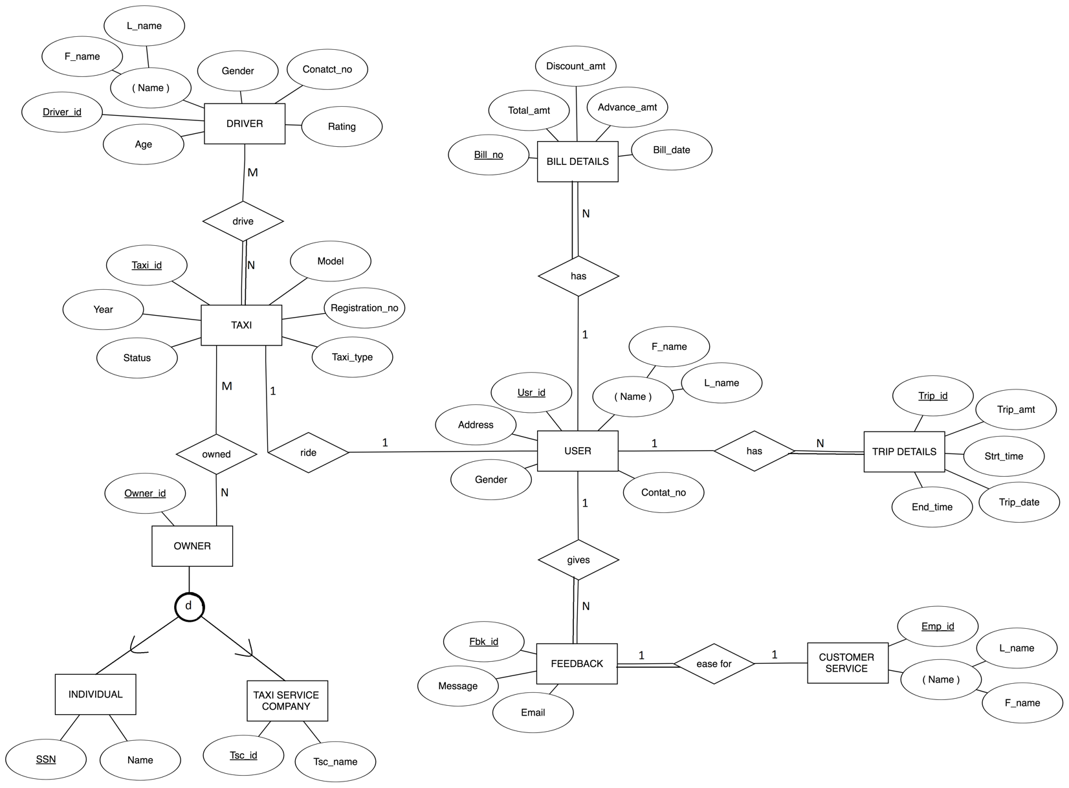

## ASSUMPTIONS:

* Many drivers can drive many taxis (M:N)
* Many owners can give many taxis at a time (M:N)
* One customer service representative can take one feedback at a time (1:1)
* Single user can have multiple trips details (1:N)
* Single user can have multiple bills details (1:N)
* Single user can give many feedbacks (1:N)
* Single user can ride in one taxi at a time (1:1)

# MAPPING OF ERD IN RELATIONAL SCHEMA

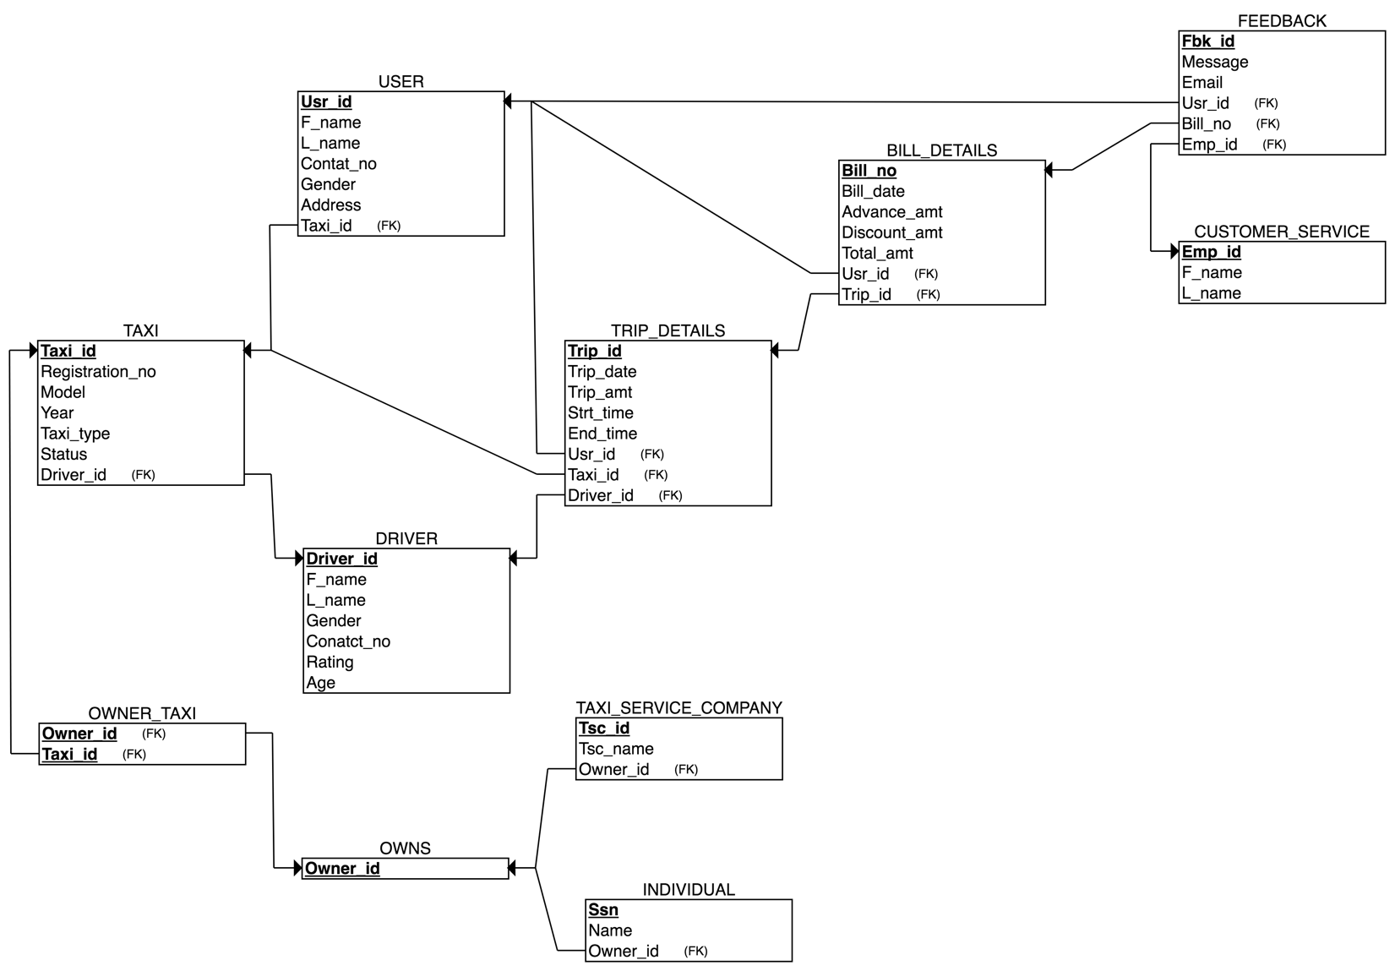

**TAXI**

|  |  |  |  |  |  |  |
| --- | --- | --- | --- | --- | --- | --- |
| Taxi_id | Registration_no | Taxi_Model | Taxi_Year | Taxi_type | Status | Driver_id |

* Primary Key: Taxi_id
* Foreign Keys: Driver_id

**USER_TBL**

|  |  |  |  |  |  |  |
| --- | --- | --- | --- | --- | --- | --- |
| Usr_id | F_name | L_name | Contat_no | Gender | Address | Taxi_id |

* Primary Key: Usr_id
* Foreign Keys: Taxi_id

**DRIVER**

|  |  |  |  |  |  |  |
| --- | --- | --- | --- | --- | --- | --- |
| Driver_id | F_name | L_name | Gender | Conatct_no | Rating | Age |

* Primary Key: Driver_id
* Foreign Keys: NA

**TRIP_DETAILS**

|  |  |  |  |  |
| --- | --- | --- | --- | --- |
| Trip_id | Trip_date | Trip_amt | Driver_id | Usr_id |

|  |  |  |
| --- | --- | --- |
| Taxi_id | Strt_time | End_time |

* Primary Key: Trip_id
* Foreign Keys: Taxi_id, Usr_id, Driver_id

**BILL_DETAILS**

|  |  |  |  |  |  |  |
| --- | --- | --- | --- | --- | --- | --- |
| Bill_no | Bill_date | Advance_amt | Discount_amt | Total_amt | Usr_id | Trip_id |

* Primary Key: Bill_no
* Foreign Keys: Usr_id, Trip_id

**CUSTOMER_SERVICE**

|  |  |  |
| --- | --- | --- |
| Emp_id | F_name | L_name |

* Primary Key: Emp_id
* Foreign Keys: NA

**FEEDBACK**

|  |  |  |  |  |  |
| --- | --- | --- | --- | --- | --- |
| Fbk_id | Message | Email | Emp_id | Usr_id | Trip_id |

* Primary Key: Fbk_id
* Foreign Keys: Usr_id, Emp_id, Trip_id

**OWNER_TAXI**

|  |  |
| --- | --- |
| Owner_id | Taxi_id |

* Primary Key: Owner_id, Taxi_id
* Foreign Keys: Owner_id, Taxi_id

**OWNS**

|  |  |
| --- | --- |
| Owner_id | No_Cars |

* Primary Key: Owner_id
* Foreign Keys: NA

**INDIVIDUAL**

|  |  |  |
| --- | --- | --- |
| Ssn | Name | Owner_id |

* Primary Key: Ssn
* Foreign Keys: Owner_id

**TAXI_SERVICE_COMPANY**

|  |  |  |
| --- | --- | --- |
| Tsc_id | Tsc_name | Owner_id |

* Primary Key: Tsc_id
* Foreign Keys: Owner_id

# SQL STATEMENS FOR TABLE CREATION

----------------------------------------------

-- Table Creation

----------------------------------------------

CREATE TABLE TAXI (

Taxi_id integer NOT NULL,

Registration_no VARCHAR(20),

Taxi_Model VARCHAR(20),

Taxi_Year DATE,

Taxi_type VARCHAR(20),

Status VARCHAR(20),

Driver_id integer,

PRIMARY KEY (Taxi_id),

UNIQUE (Registration_no)

);

CREATE TABLE USER_TBL (

Usr_id integer NOT NULL,

F_name VARCHAR(20),

L_name VARCHAR(20),

Contat_no integer,

Gender VARCHAR(10),

Address VARCHAR(50),

Taxi_id integer,

PRIMARY KEY (Usr_id)

);

CREATE TABLE DRIVER (

Driver_id integer NOT NULL,

F_name VARCHAR(10),

L_name VARCHAR(20),

Gender VARCHAR(10),

Conatct_no VARCHAR(20),

Rating integer,

Age integer,

PRIMARY KEY (Driver_id)

);

CREATE TABLE TRIP_DETAILS (

Trip_id integer NOT NULL,

Trip_date DATE,

Trip_amt decimal(10,2),

Driver_id integer,

Usr_id integer,

Taxi_id integer,

Strt_time TIMESTAMP,

End_time TIMESTAMP,

PRIMARY KEY (Trip_id)

);

CREATE TABLE BILL_DETAILS (

Bill_no integer NOT NULL,

Bill_date DATE,

Advance_amt decimal(10,2),

Discount_amt decimal(10,2),

Total_amt decimal(10,2),

Usr_id integer,

Trip_id integer,

PRIMARY KEY (Bill_no),

);

CREATE TABLE CUSTOMER_SERVICE (

Emp_id integer NOT NULL,

F_name VARCHAR(20),

L_name VARCHAR(20),

PRIMARY KEY (Emp_id)

);

CREATE TABLE FEEDBACK (

Fbk_id integer NOT NULL,

Message VARCHAR(140),

Email VARCHAR(50),

Emp_id integer,

Usr_id integer,

Trip_id integer,

PRIMARY KEY (Fbk_id),

);

CREATE TABLE OWNS (

Owner_id integer NOT NULL,

No_Cars integer,

PRIMARY KEY (Owner_id)

);

CREATE TABLE OWNER_TAXI (

Owner_id integer NOT NULL,

Taxi_id integer,

PRIMARY KEY (Owner_id, Taxi_id)

);

CREATE TABLE INDIVIDUAL (

Ssn integer NOT NULL,

Name VARCHAR(20),

Owner_id integer,

PRIMARY KEY (Ssn)

);

CREATE TABLE TAXI_SERVICE_COMPANY (

Tsc_id integer NOT NULL,

Tsc_name VARCHAR(20),

Owner_id integer,

PRIMARY KEY (Tsc_id)

);

# SQL STATEMENS FOR FORIGN KEY CREATION

----------------------------------------------

-- Foreign key creation

----------------------------------------------

ALTER TABLE TAXI ADD CONSTRAINT fketadr FOREIGN KEY (Driver_id) REFERENCES DRIVER(Driver_id) ON DELETE CASCADE;

ALTER TABLE USER_TBL ADD CONSTRAINT fkusta FOREIGN KEY (Taxi_id) REFERENCES TAXI(Taxi_id) ON DELETE CASCADE;

ALTER TABLE TRIP_DETAILS ADD CONSTRAINT fktddr FOREIGN KEY (Driver_id) REFERENCES DRIVER(Driver_id) ON DELETE CASCADE;

ALTER TABLE TRIP_DETAILS ADD CONSTRAINT fktdusr FOREIGN KEY (Usr_id) REFERENCES USER_TBL(Usr_id) ON DELETE CASCADE;

ALTER TABLE TRIP_DETAILS ADD CONSTRAINT fktdtax FOREIGN KEY (Taxi_id) REFERENCES TAXI(Taxi_id) ON DELETE CASCADE;

ALTER TABLE BILL_DETAILS ADD CONSTRAINT fkbdtd FOREIGN KEY (Trip_id) REFERENCES TRIP_DETAILS(Trip_id) ON DELETE CASCADE;

ALTER TABLE BILL_DETAILS ADD CONSTRAINT fkbdusr FOREIGN KEY (Usr_id) REFERENCES USER_TBL(Usr_id) ON DELETE CASCADE;

ALTER TABLE FEEDBACK ADD CONSTRAINT fkfbemp FOREIGN KEY (Emp_id) REFERENCES CUSTOMER_SERVICE(Emp_id) ON DELETE CASCADE;

ALTER TABLE FEEDBACK ADD CONSTRAINT fkfbtd FOREIGN KEY (Trip_id) REFERENCES TRIP_DETAILS(Trip_id) ON DELETE CASCADE;

ALTER TABLE FEEDBACK ADD CONSTRAINT fkfbusr FOREIGN KEY (Usr_id) REFERENCES USER_TBL(Usr_id) ON DELETE CASCADE;

ALTER TABLE OWNER_TAXI ADD CONSTRAINT fkeowtax FOREIGN KEY (Taxi_id) REFERENCES TAXI(Taxi_id) ON DELETE CASCADE;

ALTER TABLE OWNER_TAXI ADD CONSTRAINT fkeowowns FOREIGN KEY (Owner_id) REFERENCES OWNS(Owner_id) ON DELETE CASCADE;

ALTER TABLE INDIVIDUAL ADD CONSTRAINT fkeinowns FOREIGN KEY (Owner_id) REFERENCES OWNS(Owner_id) ON DELETE CASCADE;

ALTER TABLE TAXI_SERVICE_COMPANY ADD CONSTRAINT fketscowns FOREIGN KEY (Owner_id) REFERENCES OWNS(Owner_id) ON DELETE CASCADE;

# SQL STATEMENS FOR INSERT COMMANDS

----------------------------------------------

-- Insert Commands

----------------------------------------------

INSERT INTO TAXI VALUES(1,'KA-15R-3367','BENZE 300',to_date('01/01/2017','mm/dd/yyyy'),'SUV','Available',1)

INSERT INTO DRIVER VALUES(1,'Abhi','Gowda','Male','4693805870',5,25);

INSERT INTO USER_TBL VALUES(1,'USER1','LNAME','123456','Male','MCCAllum','1');

INSERT INTO TRIP_DETAILS VALUES(1,to_date('01/01/2017','mm/dd/yyyy'),123,1,1,1,TO_TIMESTAMP('2017-01-01 06:14:00', 'YYYY-MM-DD HH24:MI:SS'),TO_TIMESTAMP('2017-01-01 08:14:00', 'YYYY-MM-DD HH24:MI:SS'));

INSERT INTO BILL_DETAILS VALUES(1,to_date('01/01/2017','mm/dd/yyyy'),1000.10,20.11,null,1,1);

INSERT INTO CUSTOMER_SERVICE VALUES(1,'abhi','gowda');

INSERT INTO FEEDBACK VALUES(1,'not so good','abhi@gmail.com',1,1,1);

INSERT INTO OWNS VALUES(1,1);

INSERT INTO OWNS VALUES(2,1);

INSERT INTO OWNER_TAXI (1,1);

INSERT INTO INDIVIDUAL VALUES(123,'abhi owner ind',1);

INSERT INTO TAXI_SERVICE_COMPANY VALUES (1,'abhi taxi comp',2);

INSERT INTO INDIVIDUAL values(123,'abhi owner ind',1);

INSERT INTO TAXI_SERVICE_COMPANY values (1,'abhi taxi comp',2);

# PL/SQL – PROCEDURES

## Procedure Code block for Book_Taxi

----------------------------------------------

-- Procedure Creation

-- this procedure creates a use_table entry and creates the trip and bill_detail for the trip

-- input parameters : Name , Address, Contact, Taxi_Model, Gender, Advance

----------------------------------------------

CREATE OR REPLACE PROCEDURE BOOK_TAXI

( Name IN VARCHAR2,

v_Address IN VARCHAR2,

v_Contact IN VARCHAR2,

Taxi_Model IN VARCHAR2,

v_Gender IN VARCHAR2,

Advance IN decimal,

)

AS

BEGIN

DECLARE

v_usr_id INT :=-1;

v_Trip_id INT :=-1;

v_Bill_no INT :=-1;

v_Taxi_id INT :=-1;

v_Driver_id INT :=1;

BEGIN

select MAX(Usr_id)+1 into v_usr_id from USER_TBL ;

select MAX(Trip_id)+1 into v_Trip_id from TRIP_DETAILS ;

select MAX(Bill_no)+1 into v_Bill_no from BILL_DETAILS ;

select taxi_id, Driver_id into v_Taxi_id,v_Driver_id from TAXI where Status = 'Available' and Taxi_Model = Taxi_Model;

insert into USER_TBL values(v_usr_id, SUBSTR (Name, 1, INSTR(Name,' ',1)),SUBSTR (Name, INSTR(Name,' ',1)+1,LENGTH(Name)),v_Contact,v_Gender,v_Address,v_Taxi_id);

insert into TRIP_DETAILS values(v_Trip_id,sysdate, 50,v_Driver_id,v_usr_id,v_Taxi_id,sysdate,null);

insert into BILL_DETAILS values(v_Bill_no,null,Advance,null,null,v_usr_id,v_Trip_id);

END ;

END;

/

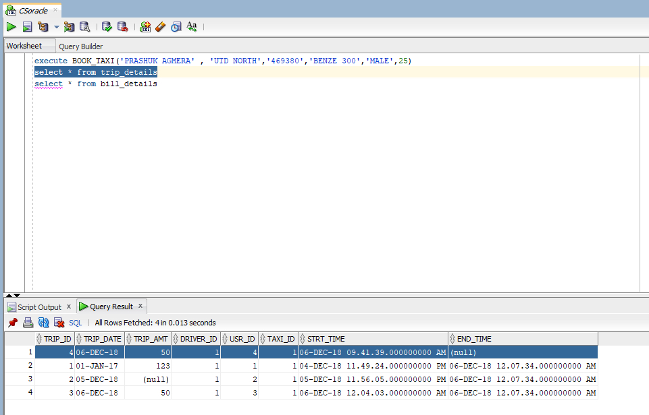

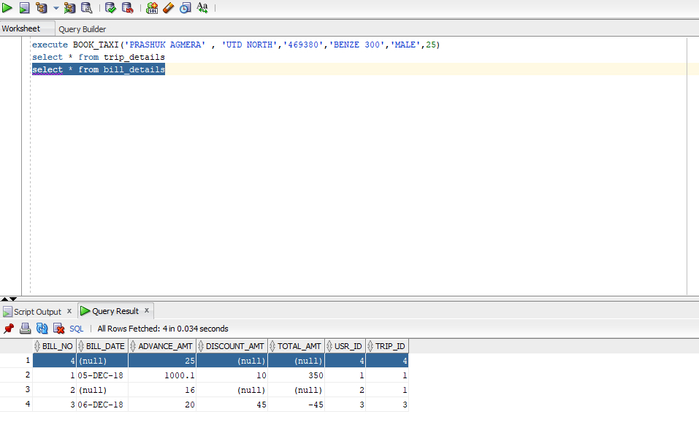

## Procedure Code block for TRIP_END

----------------------------------------------

-- Procedure Creation

-- this procedure will calculate the final amount for the trip and update the amount attributes in trip and bill details

-- input parameters :  trip_id, discount

----------------------------------------------

CREATE OR REPLACE PROCEDURE TRIP_END(v_trip IN INT , v_discount IN Decimal )

AS

BEGIN

DECLARE

v_total_time INT := -1;

v_bill_no INT :=-1;

BEGIN

select extract(day from (sysdate - Strt_time))*24 + extract(hour from (sysdate - Strt_time)) into v_total_time from TRIP_DETAILS where Trip_id = v_trip;

update TRIP_DETAILS set End_time = sysdate where Trip_id = Trip_id ;

update BILL_DETAILS set Bill_date = sysdate , Discount_amt = v_discount ,Total_amt = (v_total_time * 15) - v_discount where Trip_id = v_trip ;

END ;

END ;

/

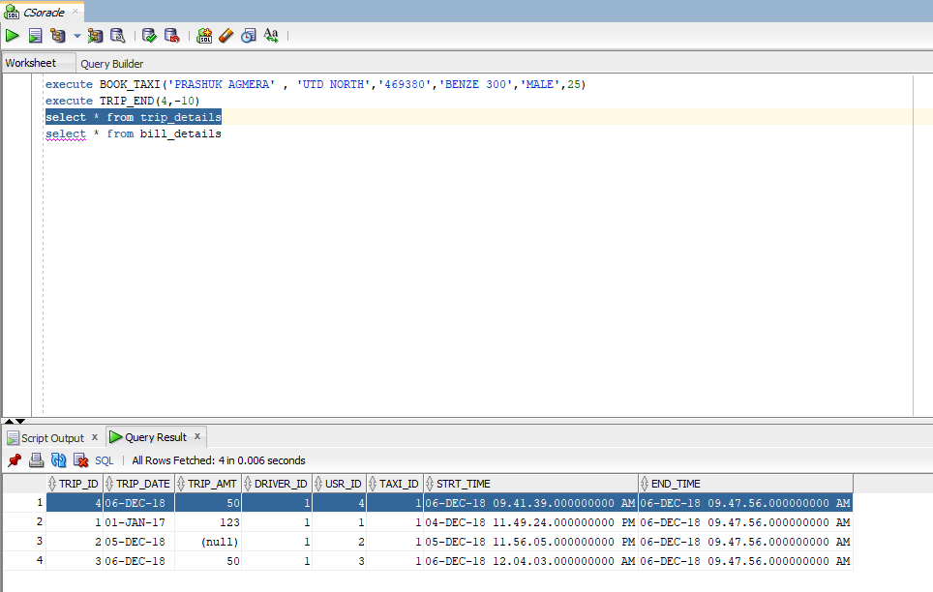

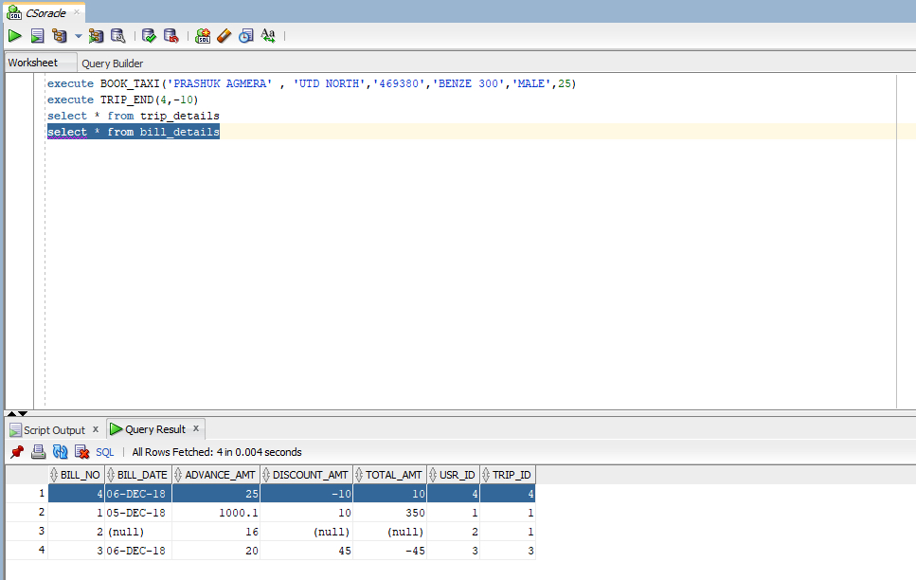

# PL/SQL – TRIGGERS

## Procedure Code block for Update_Driver_Rating

----------------------------------------------

-- Trigger Creation

-- this trigger is called when inserted(After) to the feedback table

-- the trigger will decrease the driver rating by 1 if user feed back is bad for a driver

----------------------------------------------

CREATE OR REPLACE TRIGGER UPDATE_DRIVER_RATING

AFTER INSERT ON FEEDBACK

FOR EACH ROW

WHEN (NEW.Message like '%Bad Driver%' )

DECLARE

v_driver_id INT;

BEGIN

select driver_id into v_driver_id from TRIP_DETAILS where trip_id = :NEW.Trip_id;

update DRIVER set Rating = Rating -1 where driver_id = v_driver_id;

END;

/

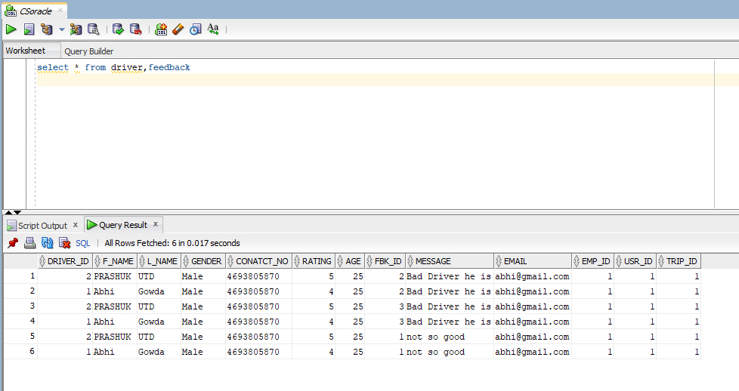

## Procedure Code block for Add_no_of_cars

----------------------------------------------

-- Trigger Creation

-- this trigger is called before the INSERT OR UPDATE ON OWNS table

-- the trigger will calculate the number of cars owned by the owner and updates the no_of_cars columns in the OWNS table

----------------------------------------------

CREATE OR REPLACE TRIGGER ADD_NO_OF_CARS

BEFORE INSERT OR UPDATE ON OWNS

FOR EACH ROW

DECLARE

v_no_of_cars INT;

BEGIN

select count(Taxi_id) into v_no_of_cars from OWNER_TAXI where Owner_id = :NEW.Owner_id group by Owner_id;

:NEW.No_Cars := v_no_of_cars;

END;

/

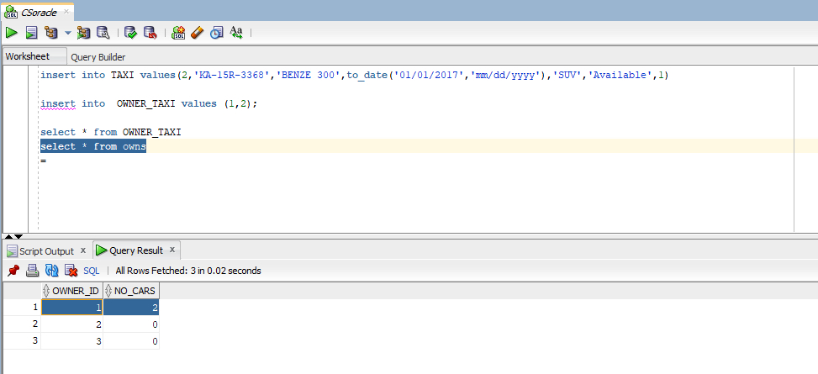

# NORMALIZATION OF RELATIONAL SCHEMA

* TAXI

{Taxi_id → Registration_no, Taxi_Model, Taxi_Year, Taxi_type, Status}

* USER

{Usr_id → F_name, L_name, Contat_no, Gender, Address, Taxi_id}

* DRIVER

{Driver_id → F_name, L_name, Gender, Conatct_no, Rating, Age}

* TRIP_DETAILS

{Trip_id → Trip_date, Trip_amt, Driver_id, Usr_id, Taxi_id, Strt_time, End_time}

* BILL_DETAILS

{Bill_no → Bill_date, Advance_amt, Discount_amt, Total_amt, Usr_id, Trip_id}

* CUSTOMER_SERVICE

{Emp_id → F_name, L_name}

* FEEDBACK

{Fbk_id → Message, Email, Emp_id, Usr_id, Trip_id}

* OWNER_TAXI

{Owner_id → Taxi_id}

* OWNS

{Owner_id → No_Cars}

* INDIVIDUAL

{Ssn → Name, Owner_id}

* TAXI_SERVICE_COMPANY

{Tsc_id → Tsc_name, Owner_id}